**ASSIGNMENT-04**

**Assignment-04:** Write code and connections in wokwi for the ultrasonic sensor. Whenever the distance is less than 100 cms send an "alert" to the IBM cloud and display in the device recent events. Upload document with wokwi share link and images of IBM cloud.

**WOKWI LINK:** https://wokwi.com/projects/346960812826427986

**SOURCE CODE:**

#include <WiFi.h>

#include <PubSubClient.h> WiFiClient

wifiClient;

#define ORG "nhpwjc"

#define DEVICE_TYPE "NodeMCU"

#define DEVICE_ID "USE YOUR ID"

#define TOKEN "USE YOUR TOKEN"

#define speed 0.034

char server[] =

ORG

".messaging.internetofthings.ibmcloud.com"; char publishTopic[]

= "iot-2/evt/Data/fmt/json"; char topic[] = "iot-2/cmd/home/fmt/String"; char authMethod[] = "use-tokenauth";

char token[] = TOKEN;

char clientId[] = "d:" ORG ":" DEVICE_TYPE ":" DEVICE_ID;

PubSubClient client(server, 1883, wifiClient); void publishData();

const int trigpin=5;

const int echopin=18;

String command;

String data="";

long

duration;

float dist;

void

setup()

{

Serial.begin(115200);

pinMode(trigpin, OUTPUT)

pinMode(echopin, INPUT); wifiConnect();

mqttConnect();

} void loop() { publishData();

delay(500);

if (!client.loop()) { mqttConnect(); }

}

void wifiConnect() {

Serial.print("Connecting to "); Serial.print("Wifi");

WiFi.begin("Wokwi-GUEST", "", 6); while (WiFi.status() !=

WL_CONNECTED) { delay(500);

Serial.print("."); }

Serial.print("WiFi connected, IP address: "); Serial.println(WiFi.localIP());

}

void mqttConnect() { if

(!client.connected()) {

Serial.print("Reconnecting MQTT client to "); Serial.println(server); while

(!client.connect(clientId, authMethod, token)) { Serial.print("."); delay(500);

} initManagedDevice(); Serial.println();

} }

void initManagedDevice() { if

(client.subscribe(topic)) {

// Serial.println(client.subscribe(topic)); Serial.println("subscribe to cmd

OK");

} else {

Serial.println("subscribe to cmd FAILED"); } } void

publishData()

{ digitalWrite(trigpin,LOW); digitalWrite(trigpin,HIGH)

delayMicroseconds(10);

digitalWrite(trigpin,LOW);

duration=pulseIn(echopin,HIGH);

dist=duration*speed/2; if(dist<100){

String payload = "{\"Alert distance\":";

payload += dist; payload += "}";

Serial.print("\n");

Serial.print("Sending payload: "); Serial.println(payload);

if (client.publish(publishTopic, (char*) payload.c_str())) {

Serial.println("Publish OK");

} else {

Serial.println("Publish FAILED"); }

}

}

**CIRCUIT:**

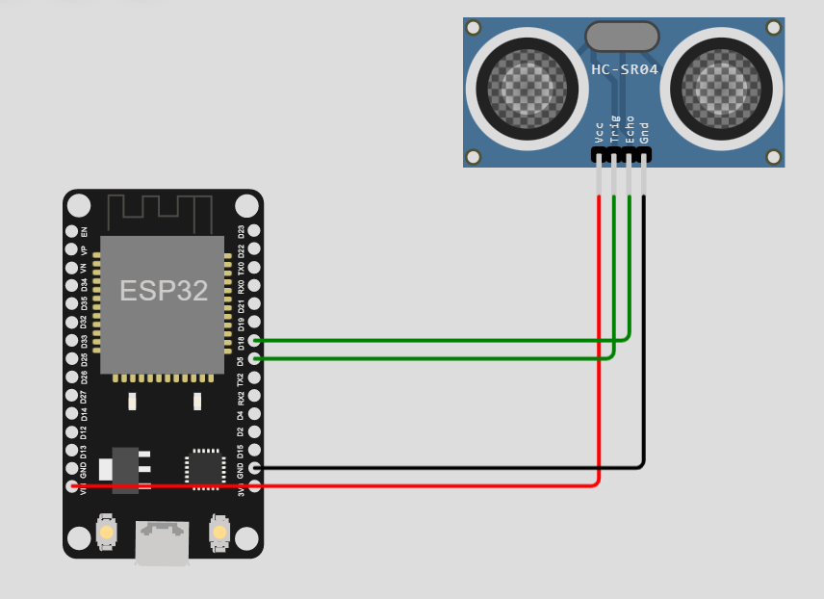

**OUTPUT:**

